Creating an Out of Office Reply
GroupWise

1. Click on Tools, then click on Rules, then click the New button.

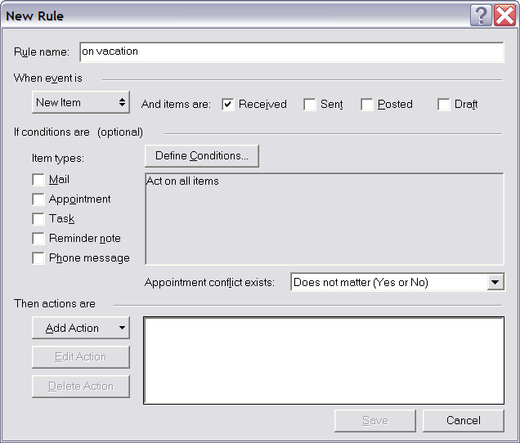
4. Call the RULE NAME: "on vacation " - you could actually use any name that suits you, but I figure this one is descriptive.

5. Click the button below the When Event Is text. It initially probably says "new item". If it doesn't say "new item" click on it and make sure it does say "new item"

6. Next to the button, there is a check box that is titled: Received. Make sure that is the ONLY box checked.

7. Make sure NONE of the "Item Types" checkboxes are selected.

8. Click the DEFINE CONDITIONS button. You will get a box that looks similar to the one below.

9. The first dropdown list should be changed to Delivered (as shown below)

10. The second button can be clicked on to change it from “=” to “after”
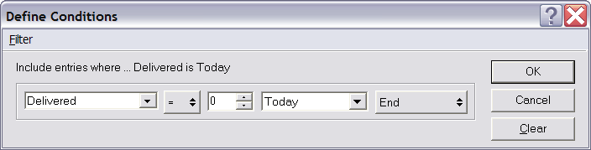

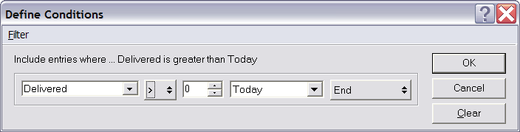
The symbol will change to a >

12. Click the OK button
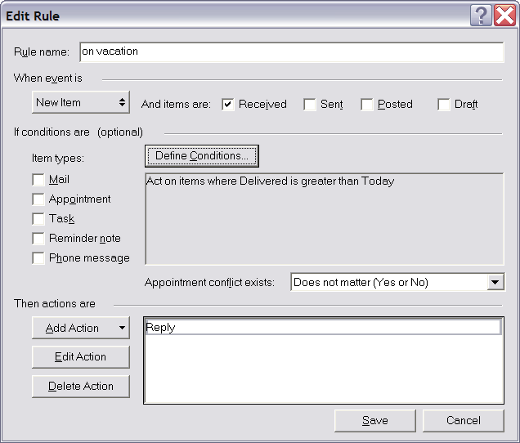
13. You will go back to the main screen, but the middle of it will say something like this:

In other words, any emails delivered to you after today will get a response from the computer.

14. Click on the ADD ACTION button, and then choose the option to REPLY. And Reply to Sender will be selected. Leave that as is and press OK.

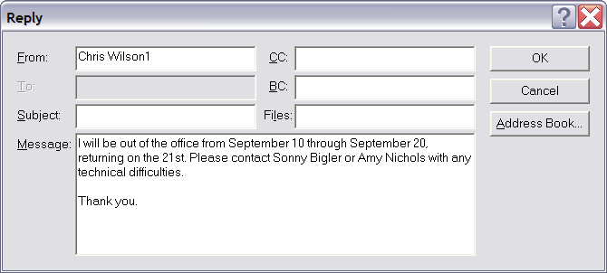
15. Type in your message you want to reply with (see below).

16. When you are done, press the OK button.

17. Click the SAVE button to save this new “rule”

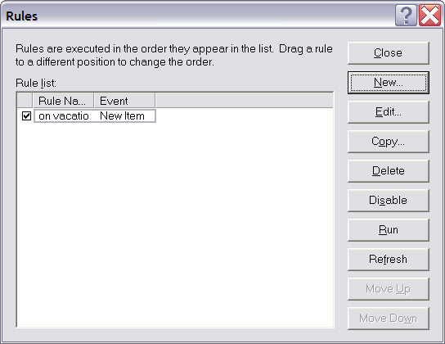
18. Now you will see the main screen once again. There will be a checkbox next to your new rule. This means that is currently ON. If you aren’t going to be going on vacation right now, then turn it OFF by clearing the checkbox.

19. Whenever you turn that checkbox on in the future, it will display your “on vacation” message from that day forward.

20. Exit this “Rules” window by clicking the CLOSE button.

When you get back, you must remember to clear that checkbox to turn this rule OFF so the computer doesn’t keep sending out the “on vacation” reply.

Going Back and Turning ON and OFF the “on vacation” Message in the Future

- Click on Tools on the menubar, then click Rules.
- You will see the last screen shown above. Simply turn ON or OFF the “vacation rule” by clearing or checking the checkbox.

That’s it!

